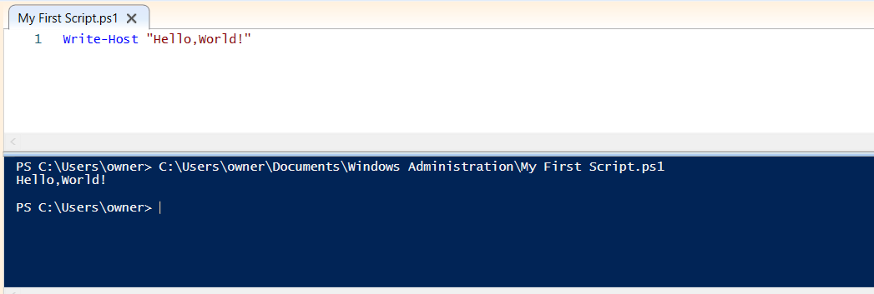

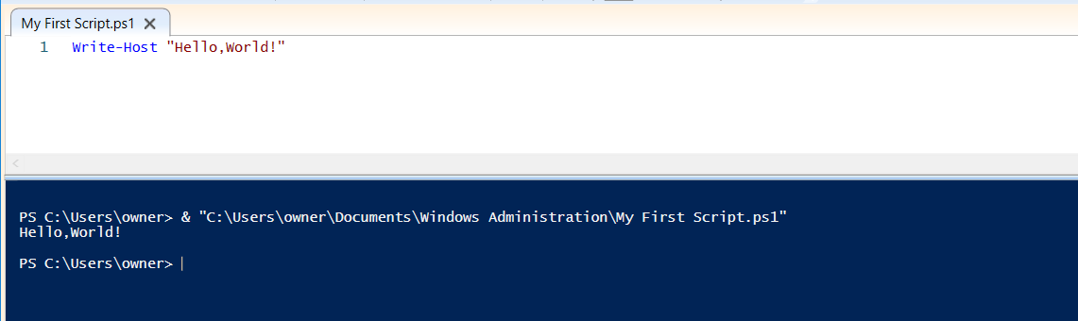

gci variable:

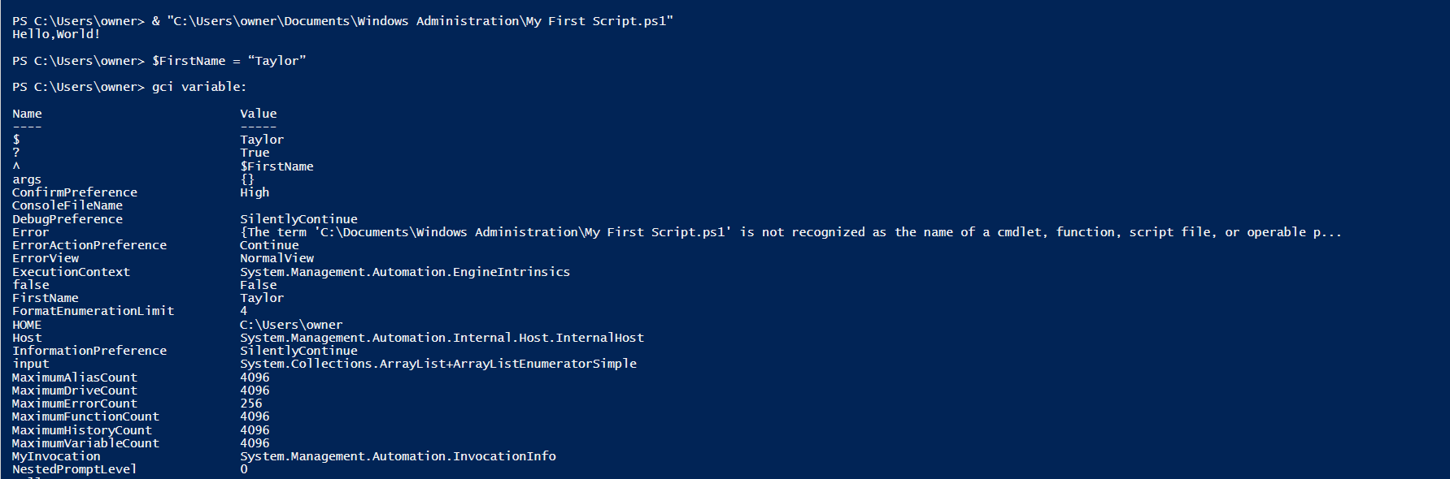

Remove-Item Variable:\FirstName

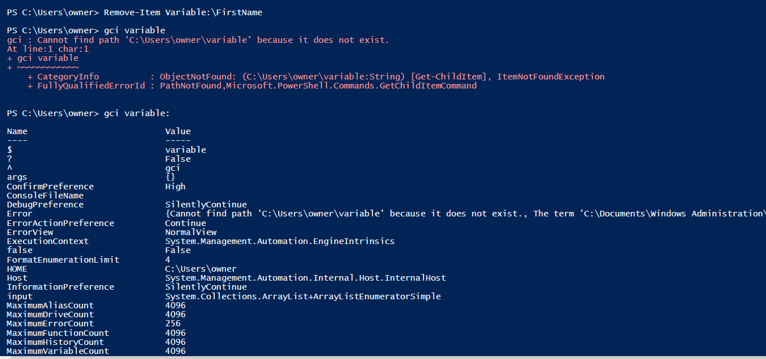

$Proc

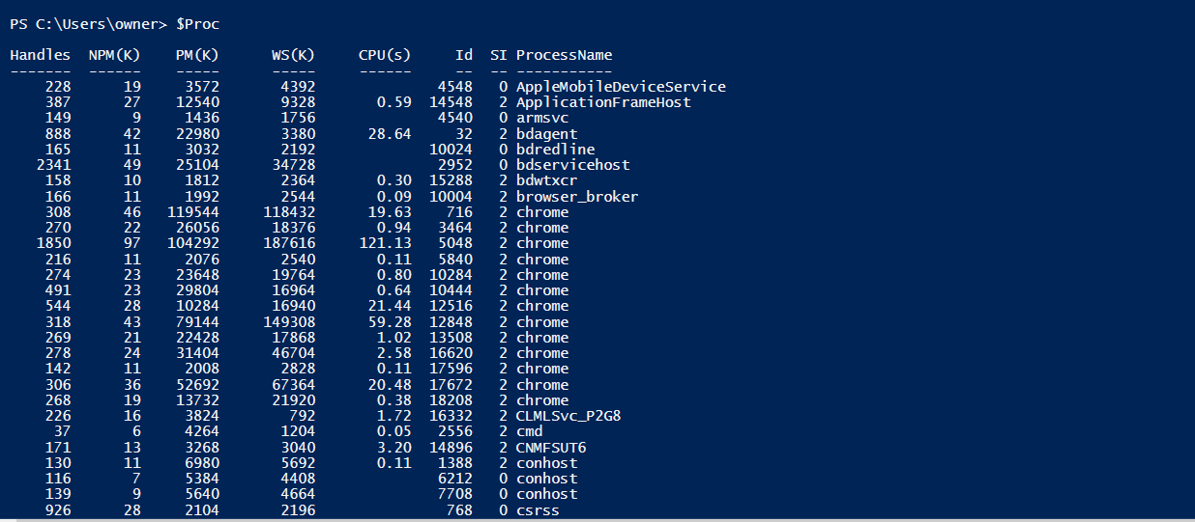

$CPUHogs

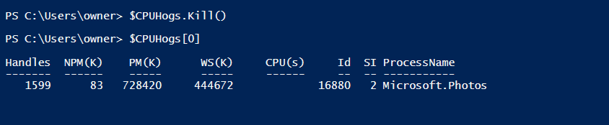

$CPUHogs[0]

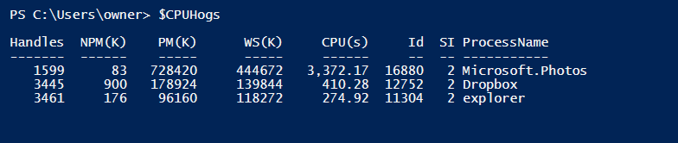

$FirstName = Read-Host –Prompt ‘Enter your first name’



$FirstName



Write-Output “How-To Geek Rocks!”



Write-Host –NoNewLine “Counting from 1 to 9 (in seconds): “

foreach($element in 1..9){

Write-Host –NoNewLine “${element} “

Start-Sleep –Seconds 1

}

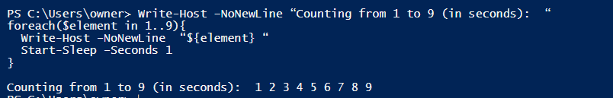

Write-Host –NoNewLine “Counting from 1 to 9 (in seconds): “

foreach($element in 1..3){

Write-Host –NoNewLine “${element} ” -BackgroundColor “Green” -ForegroundColor “Black”

Start-Sleep –Seconds 1

}

foreach($element in 4..6){

Write-Host –NoNewLine “${element} ” -BackgroundColor “Yellow” -ForegroundColor “Black”

Start-Sleep –Seconds 1

}

foreach($element in 7..9){

Write-Host –NoNewLine “${element} ” -BackgroundColor “Red” -ForegroundColor “Black”

Start-Sleep –Seconds 1

}

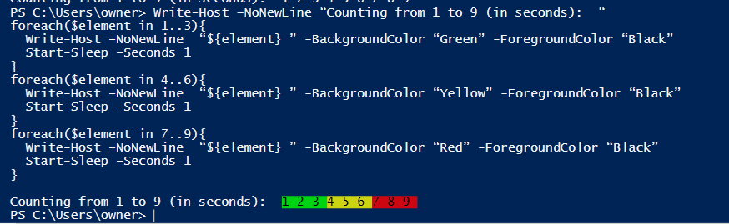

Write-Host “Phase 1”

$start=Get-Date

Write-Output $start

Write-Host “Phase 2”

Start-Sleep -Seconds 5

Write-Host “Phase 3”

$end=Get-Date

Write-Output $end

Write-Host “Phase 4”

$diff=New-TimeSpan $start $end

Write-Output $diff

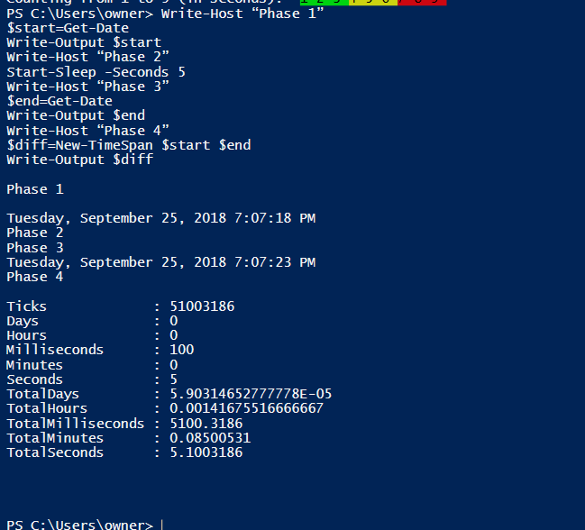

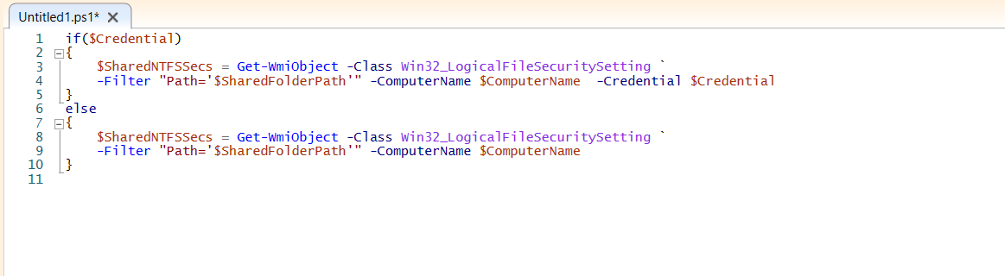

**$cre = Get-Credential “DESKTOP-2FHT4SG \Administrator”**



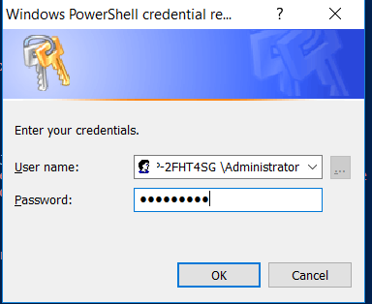

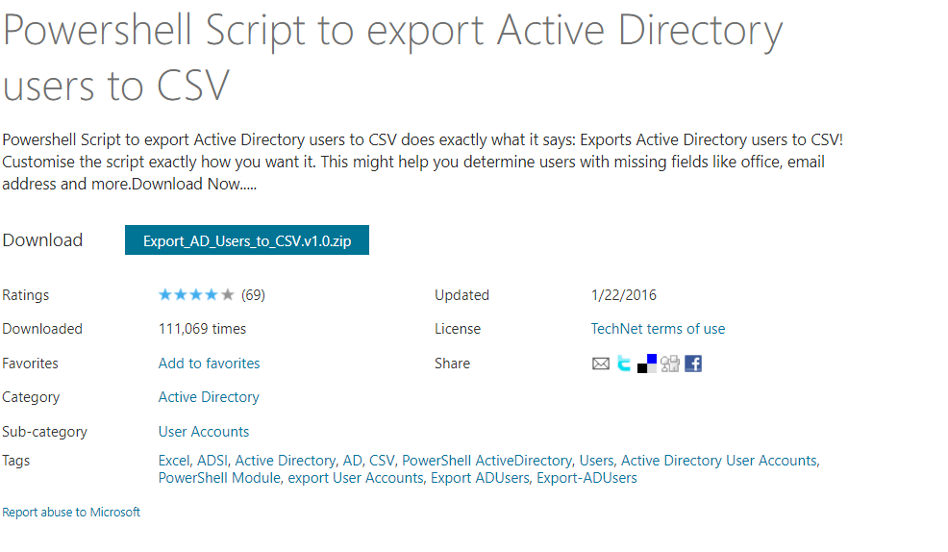

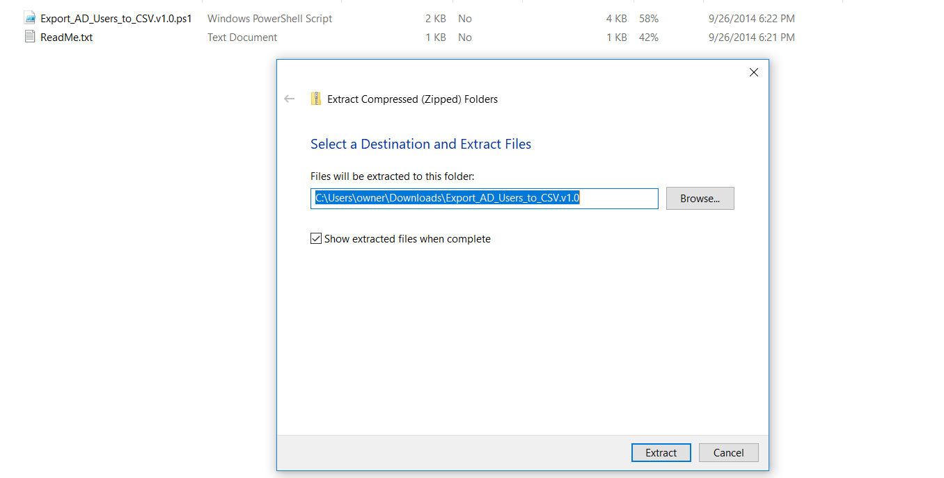

**Portion of script showing exported user fields**:

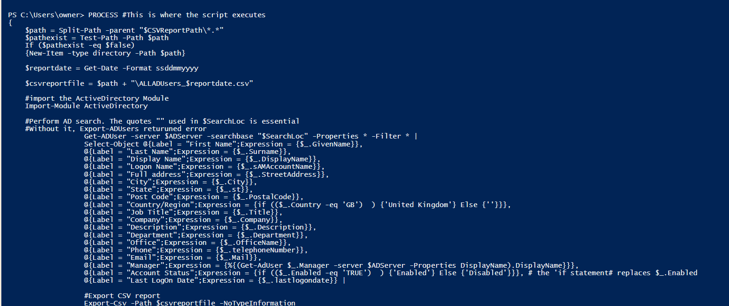

PS C:\> Get-Culture

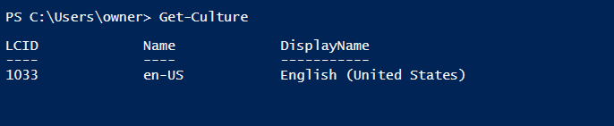

PS C:\> $C | Format-List -Property *

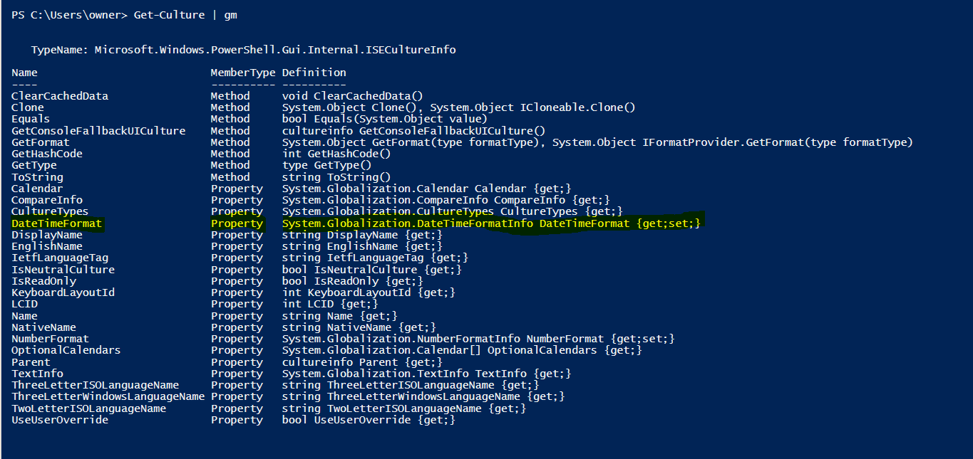

Get-Culture

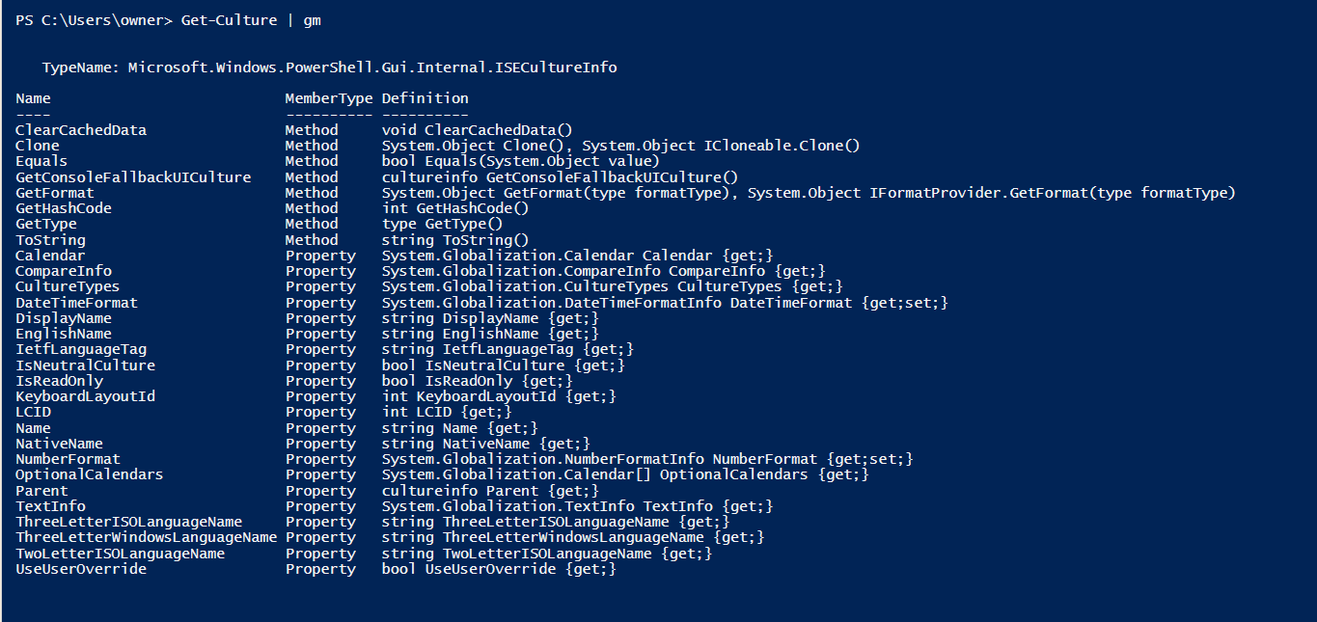

Get-Culture.Datetimeformat

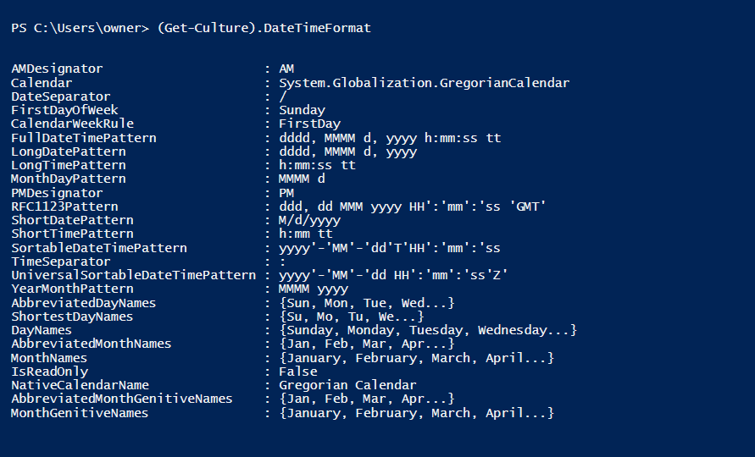

$cultures = "en-US","en-GB","fr-CA","fr-FR","ms-MY","zh-HK"

foreach ($c in $cultures)

{

 $culture = New-Object system.globalization.cultureinfo($c)

 $date = get-date -format ($culture.DateTimeFormat.ShortDatePattern)

 New-Object psobject -Property @{"name"=$culture.displayname; "date"=$date}

}

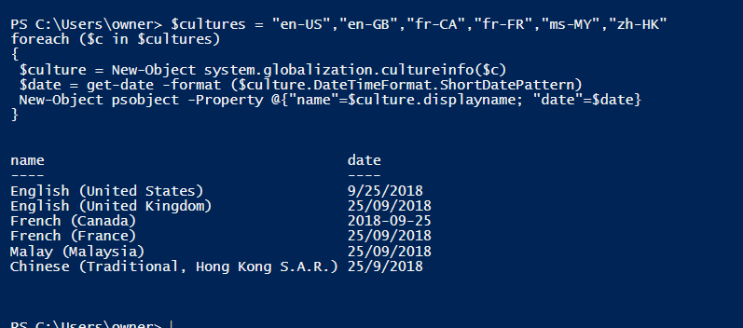

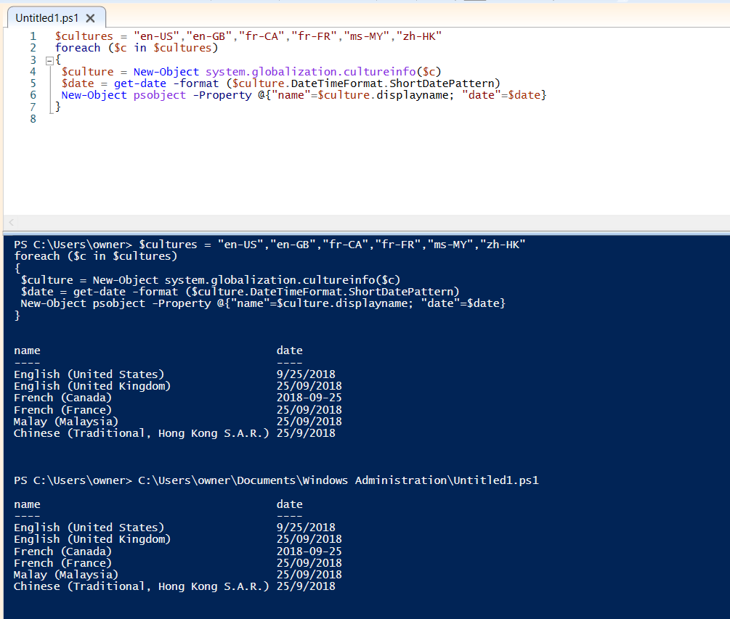

Help show command

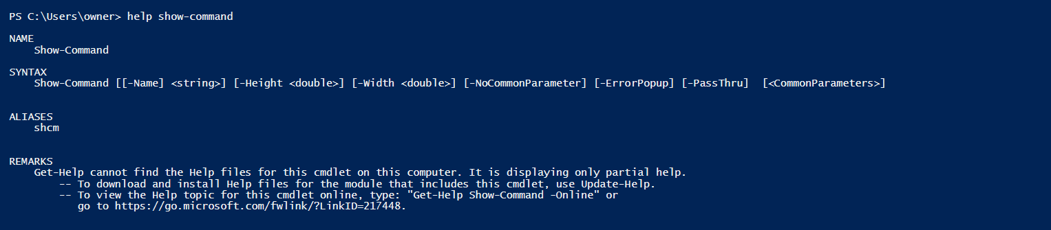

**Show-Command -Name "Invoke-Command"**

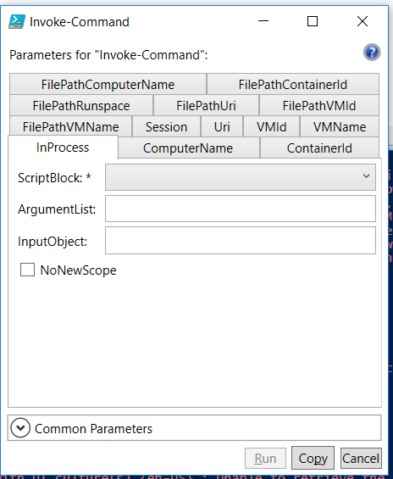

**:\> Show-Command -Name "Connect-PSSession" -Height 700 -Width 1000 -ErrorPopup**

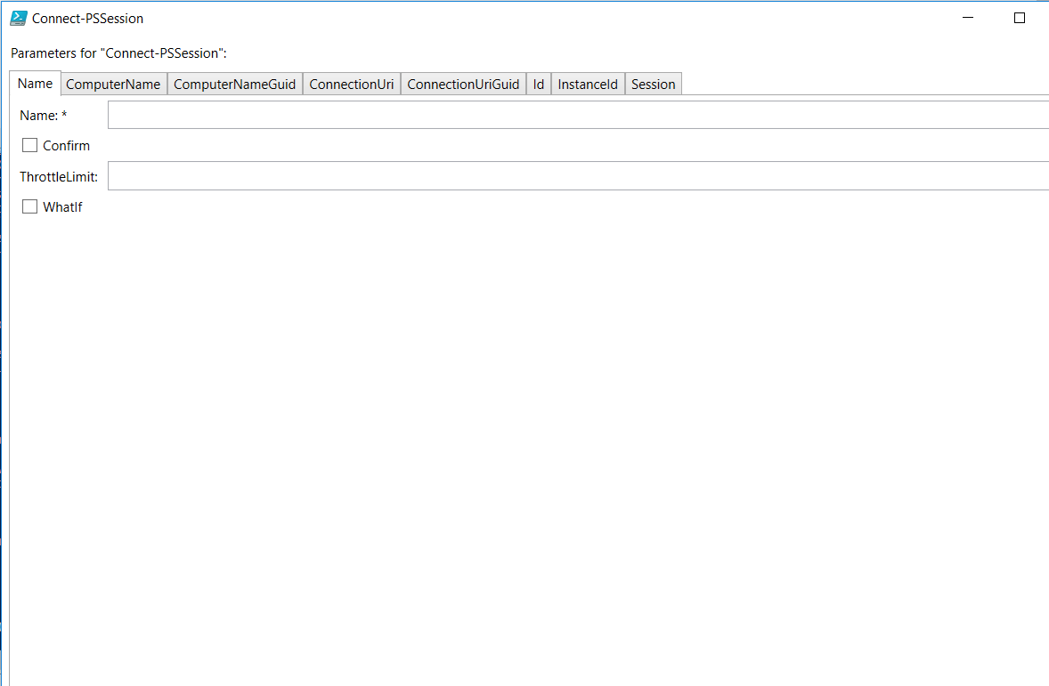



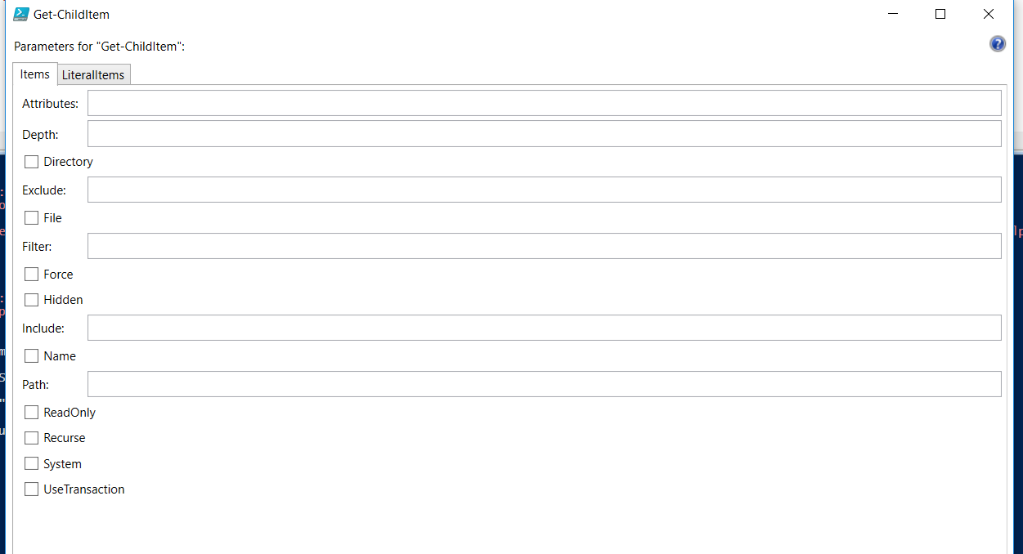

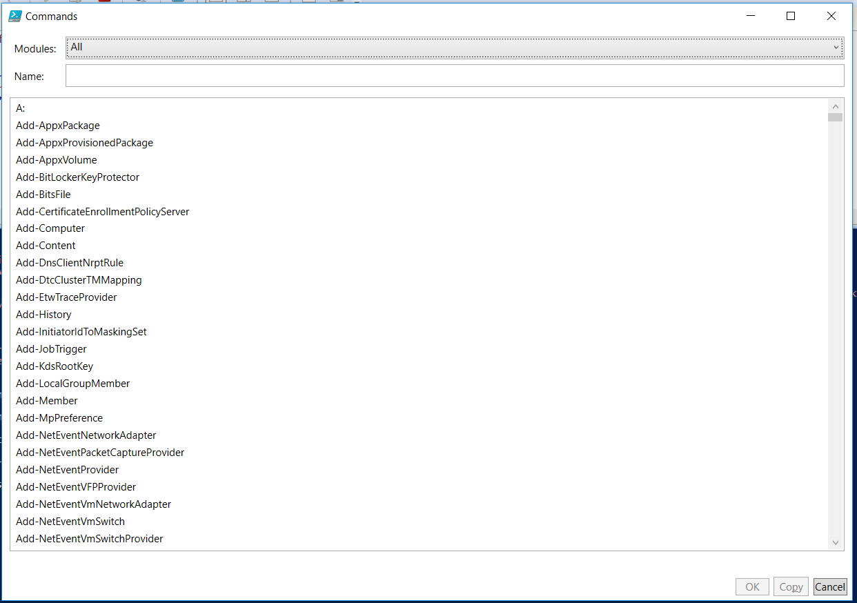

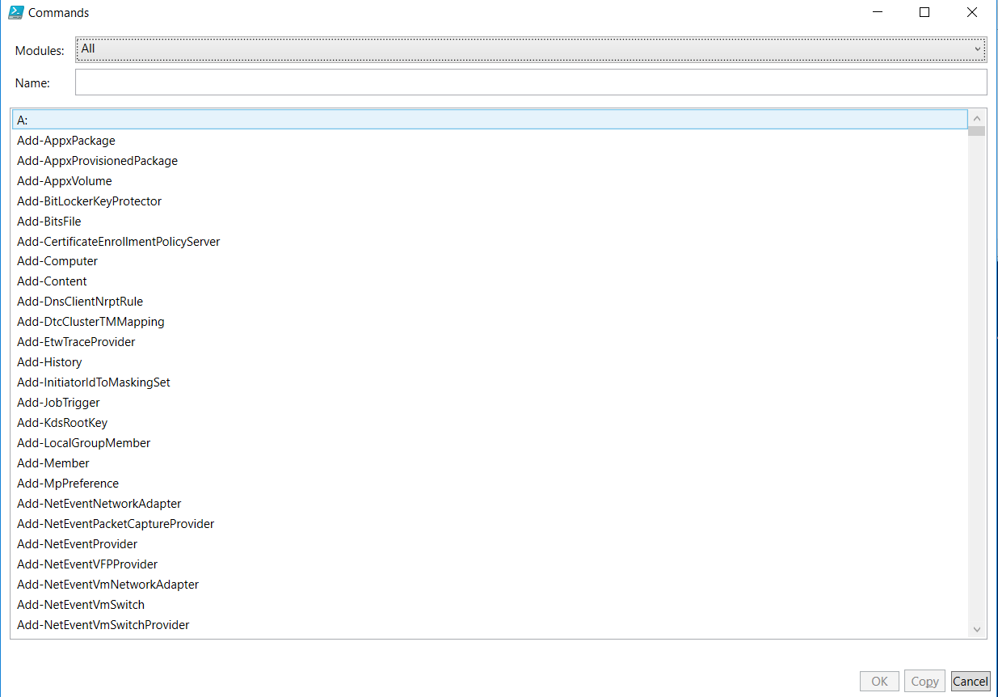

**$C Get-EventLog -LogName "Windows PowerShell" -Newest 5**

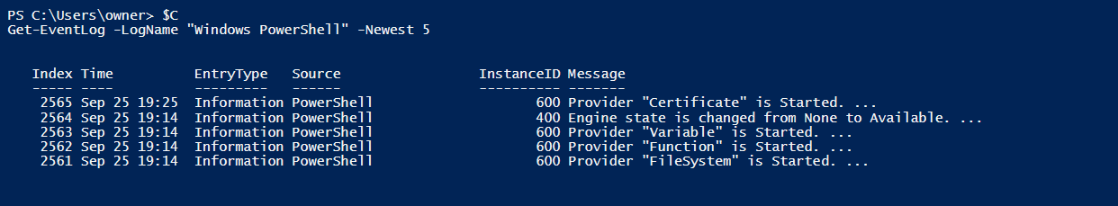

**Invoke-Expression $C**

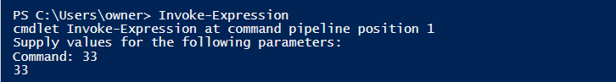

**PS C:\> iex $C**

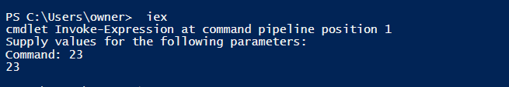

**$P = Show-Command Get-Process -ErrorPopup**

